List

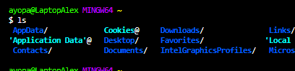

Change Directory



Make directory

//Create file



Start

Remove



Remove folders



Current route

Node.JS

Print working directory

Use node to Run this file

Node– write code directly

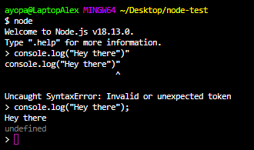

Double Tab for autofill possibilities

.exit or Control + C (x2) – To end process

Clear console

